COPYRIGHT TRANSFER AGREEMENT FORM

Title of Manuscript : Understanding CDA: Histories, Remembering, and Futures
Name of Principal Authors : Siti Rafiah. MH
Address of Principal Authors : Komp. Graha Tj. Indah Blok K.8, Pekanbaru-Indonesia. 28262.
Email : srafiah297@gmail.com
Phone Number : +628 239 065 8795

(You can add more Authors as second, third Author, etc)

- I/We submit to the Script Journal, Journal of Linguistic and English Teachingthe above manuscript. I/We certify that the work reported here has not been published before and contains no materials the publication of which would violate any copyright or other personal or proprietary right of any person or entity.

- I/We hereby agree to transfer to Department of English Language,Teacher Training and Education Faculty, Widya Gama Mahakam University, Samarinda, East Kalimantan the copyright of the above - named manuscript. I/We reserve the following:
- All proprietary rights other than copyright such as patent rights.
- The right to use all or part of this article in future works of our own such as in books, lectures, and references.

Indonesia, Pekanbaru, 22nd May 2018
Siti Rafiah. MH
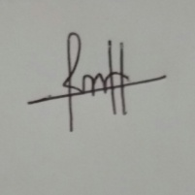
(Original Signature)
(if the article has more than one author, only the first author signature will suffice)

